Terms & Conditions
At Zensational Minds our aim is to welcome you with a view to getting you feeling better, more positive and able to confidently deal with anything that life throws at you.
If you have any questions at any point throughout the course of your appointment, please do not hesitate to ask. Please refer to our Terms and Conditions of Business below to help you understand how we operate.
Payment Terms
Mrs Leigh Tanner trading as Zensational Minds needs to inform the client about their payment terms in order that they are clear, and the focus is on the client’s treatment. Unless an approved third party has guaranteed the client’s account, or previously agreed with Mrs Tanner it must be settled in full by the day of treatment. After payment, future appointments must be made, if a session is not taken and attended by the customer for 6 weeks after most recent session, treatment will be cancelled and any outstanding payments will forfeited by the customer.
Methods and Responsibility of Payment
Zensational Minds accepts cash and bank transfers. Bank transfers must be made in advance so that funds are cleared by the day of treatment. Zensational Minds accepts direct payment arrangements only from the patient or a third party with whom we have a prior arrangement. Some client’s employers will agree to pay for any excess or shortfall payments but unless we have a prior arrangement with them in writing, the client must settle their account with Zensational Minds and then recover the balance from their employer.
Cancellations & Missed Appointments
When the client makes an appointment, an agreed period of time is held for them. Appointments that are cancelled, not attended (DNA) or rescheduled will be charged at the full fee if the client fails to give 24 hours’ notice of non-attendance.
Data Protection
Zensational Minds Limited strictly abides by and adheres to the GDPR 2018, which sets rules for the processing of personal information. It applies to both manual and computer records.
Clients have the right to access information held about them either electronically or in paper format. Clients who wish to obtain this information will need to contact the Zensational Minds directly by email on zensationalminds@outlook..com who will arrange for the client to sign a Release of Records Form. There will be an applicable administrative charge of £50.
Consent
At Zensational Minds, it is my duty to help you reach your goals by using many different types of techniques, such as:
- Hypnotherapy
- Mindfulness
- Meditation
- Positive Psychology
- NLP
- CBT
- EFT
- Life Coaching
- Homework
I agree, that for the duration of time that I am working alongside Mrs Leigh Tanner I will actively and enthusiastically participate in all techniques suggested and recommended to me. I understand that these techniques have been thoroughly researched and tested by Mrs Leigh Tanner personally. If I find myself facing difficulties, I will openly discuss these with Leigh who will address any concerns professionally and with empathy.
I understand that these techniques that are given, are done for the good of my progression. Therefore if I refuse to participate without adequate reason, Mrs Leigh Tanner trading as Zensational Minds will be legally within her right to cancel treatment without refund.
Confidentiality
Mrs Leigh Tanner trading as Zensational Minds is committed to maintaining strict confidentiality. This means that when accessing patient information Zensational Minds looks at the following conditions:
  - Justify the purpose.
  - Use patient identifiable information only if it is absolutely necessary and legally permissible.
  - Ensure that patient identifiable information is accessed only on a strict need to know basis.
  - Ensure that everyone with access to patient identifiable information is aware of their responsibilities.
  - Understand and comply with the GDPR 2018.
When working with Children, all discussions will be kept private unless the child or young person (below 18 years old) either;
- Asks for a subject to be brought up with their parent or guardian or their behalf
- Speaks of suicidal thoughts or actions
- Discusses self harm
If any of the above is discussed Mrs Leigh Tanner reserves the right to disclose information to the parent/guardian or medical professional.

Signed.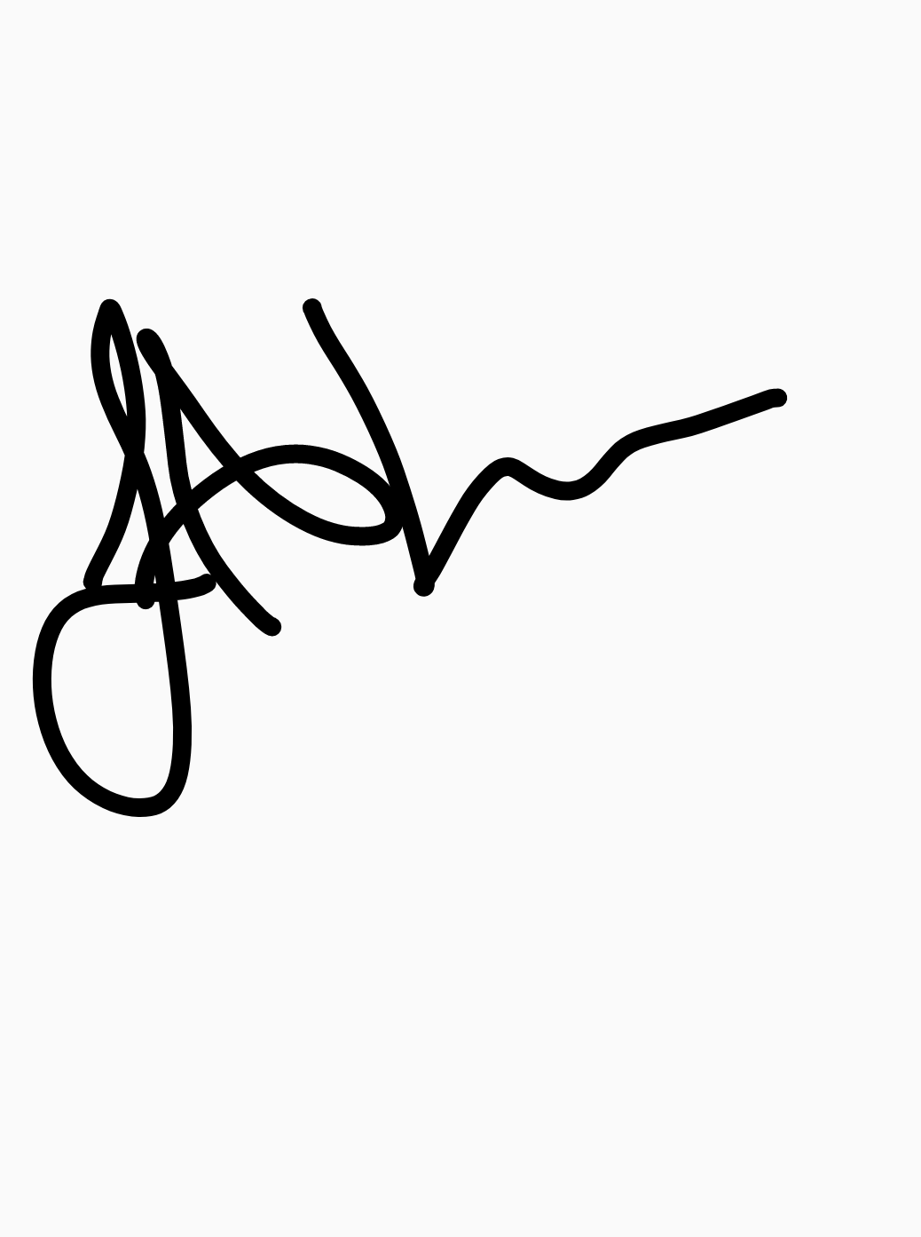
Date. 12th November 2021

